
FAIR data engineering – 2024-2025

Fair LOANS
Fairification of loan data

Kiona Bijker (s1979418)
ragunath seenivasagan ( s3482820)

-2025

FAIR LOANs
Fairification of loan data

Kiona Bijker (s1979418)
ragunath seenivasagan ( s3482820)

16-09-2025



TABLE OF CONTENT

1. Introduction 3
2. FAIRification planning 4
2.1 FAIRification goals 4
2.2 Target resource(s) 4
2.3 Target stakeholders 4
2.4 Reuse stakeholders 4
2.5 FAIRification requirements 4
2.6 Semantic types 4
2.7 Competency questions 4
3. FAIRification process 4
3.1 initial fairness assessment 4
3.2 Semantic data model 5
3.3 Data triplification 6
3.4 Semantic metadata model 9
3.5 Metadata and data publication 9
3.6 Final FAIRness assessment 9
4. discussions and Conclusions 10
5. annexes 11

Introduction
Within this project we will be FAIRifying the ‘Lending Club’ dataset. This is a financial dataset of various loans containing 27 columns and a little over a million rows in a csv format. The dataset is available at https://datasetsearch.research.google.com/search?query=lending%20club%20-site%3Akaggle.com&docid=L2cvMTFzand2ZHJzYg%3D%3D and published under the CC0 Public domain license.
We have some financial expertise in the team as Ragunath Seenivasagan used to be a Data Steward in the banking sector. To reduce workload we will filter to records including unique/rare values (such as ‘Joint App’) and add from the remaining rows at random. In this project we will be using 1000 rows and the following columns:
Name column | Description | Type
issue_d | Issue date of loan | Date
sub_grade | Grade awarded to person requesting loan, seems to determine interest rate | String, may be enumerable
term | Time to pay back loan | Integer “months”
home_ownership | Seems to be MORTGAGE or RENT | String, may be enumerable
fico_range_low | Low end of the credit score | Integer
pub_rec | Public records on person (criminal, bankruptcy, etc. anything filed in courts) | Integer
revol_util | Revolving credit line utilisation rate (use loan as source for other loan application or as a balance to take from as needed) | Decimal number
int_rate | Interest rate | Decimal number
application_type | Mainly ‘Individual’ some ‘Joint App’, describes number of people applying | String, may be enumerable
verification_status | Verified, Not Verified, or Source Verified. ID and other truth checks in loan application | String, may be enumerable
addr_state | State the registered address of applicant is located in | String, may be enumerable
fico_range_high | High end of the credit score | Integer
id | ID of loan application | Integer
emp_length | Duration of total employment | Integer
loan_status | Loan approved or not | 1 or 0, boolean

FAIRification planning

FAIRification goals
- G1 (Findable): Use w3id PIDs for the dataset, versions, and core entities (loans, borrowers). Publish indexable DCAT/Dublin Core metadata.
- G2 (Accessible): Release CSV and RDF/JSON-LD via HTTPS; keep metadata always open. Version every snapshot.
- G3 (Interoperable): Generate RDF with OpenRefine (RDF extension).Use Protégé to align schema to FIBO-Loan, schema.org; export JSON-LD context.
- G4 (Reusable): Provide license, data card, quality and fairness notes; validate with SHACL and publish the reports.
- G5 (Responsible add-on): Mark sensitive/proxy attributes; publish fairness diagnostics and usage cautions.

Target resource(s)

Resource | Description
loans.csv | Main dataset with loan information (issue date, sub-grade, term, etc.)
loans.ttl / loans.jsonld | RDF/JSON-LD exports created with OpenRefine RDF extension
lc-ontology.ttl | Ontology designed in Protégé linking dataset fields to FIBO and schema.org
shapes.ttl, validation-report.ttl | SHACL constraints and validation results
DCAT-metadata.ttl | FAIR metadata record describing the dataset
prov.ttl | Provenance file describing how FAIRification was performed
/.htaccess (w3id repo) | Redirect rules mapping w3id URIs to live dataset locations

Target stakeholders
- Data owners or stewards: Course/research data stewards; dataset maintainers.
- Data engineers: People building features, pipelines, and models on Lending Club data.
- Subject Matter Experts: Credit risk analysts, economists.
- Governance/compliance: Research ethics boards, DPOs, EU AI Act/GDPR compliance teams
- Educators or students: Using the corpus for teaching ML/fairness

Reuse stakeholders
- Academia: Fairness/bias researchers; reproducibility studies
- Industry: FinTech risk teams, explainability tooling vendors
- Policy & audit: Auditors/regulators evaluating model fairness & documentation
- Open-source community: Benchmark creators
- Civic tech & NGOs: Consumer-rights orgs studying credit access equity

FAIRification requirements
- Columns containing personal or identifying details must remain pseudonymous.
- Use standard ontologies like Financial: fibo-loan:Loan, fibo-loan:CreditScore, fibo-loan:InterestRate
- Validate using SHACL constraints for required and range-restricted fields.
- Release under CC0 with a documented citation.
- Keep data accessible via HTTPS and maintain integrity with checksums.
- Document OpenRefine transformation steps in the provenance file.

Semantic types
Classes
- fibo-loan:LoanApplication — all loan rows.
- fibo-fnd:Requester — also typed on the same loan resources.
- fibo-fbc:CreditRatingScale — intended for nodes like …/A1, A2, B2, C2, D1.
- wd:Q157470, wd:Q852446 — Wikidata items used as classes
Object properties
- QualitativeRatingScore (from FND/Ratings) — links a loan to its grade node (e.g., …/A1).
- wiki:Q319608 used as a predicate to point to a state item.
Datatype properties
- owl:hasKey — used as if it were a data property for loan id.
- ex:loanIssueDate — xsd:dateTime.
- hasContractDuration — xsd:int (months).
- hasInterestRate — xsd:double .
- fibo_loan:LoanApplicationStatus — xsd:boolean (1/0).
- Local literals under http://localhost:3333/:
  - isVerified (“Verified/Not Verified/Source Verified”)
  - isOfType (“Individual”)
  - has (“MORTGAGE/RENT”) → home ownership
  - Employment → xsd:int (years)
- fibo_loan:IndividualPersonCreditRating — integers (two values = FICO low/high).
- fibo_loan:PublicRecord — integer count.

Competency questions
- How can a user query for all approved loans (loan_status = 1) issued after a specific date?
- What is the average interest rate grouped by sub_grade or application_type?
- How can we retrieve the FICO score range and associated interestRate for a given loan?

FAIRification process

initial fairness assessment
Principle # | Criteria | Conformance | Note
F1 | Globally unique identifier | partially | Identifier is unique within dataset but likely no longer unique when combining data across banks
F1 | Persistent identifier | no | Unknown, no persistence policy given
F2 | Has metadata | yes | Found on kaggle and figshare
F2 | Has rich metadata | partially | Provides license and some provenance
F3 | Has data identifier in metadata | yes | Link provided
F3 | Has data identifier with clear predicate in metadata | no | Just DOI under “unique identifier” predicate
F4 | Indexed/registered in search resource | yes | Google dataset search
A1 | Has resolution protocol | yes | HTTP
A1.1 | Protocol is open, free and universally implementable | yes
A1.2 | Protocol has authentication and authorisation mechanisms | yes | HTTPS has these
A2 | Metadata has longer persistency than data | no | There is no clear policy to retain metadata after the dataset is no longer available
I1 | (meta)data | no | Column names are unclear, do seem to be somewhat common use

Semantic data model
Based on our joint knowledge of the domain we came up with the following initial sketched model (made with draw.io).
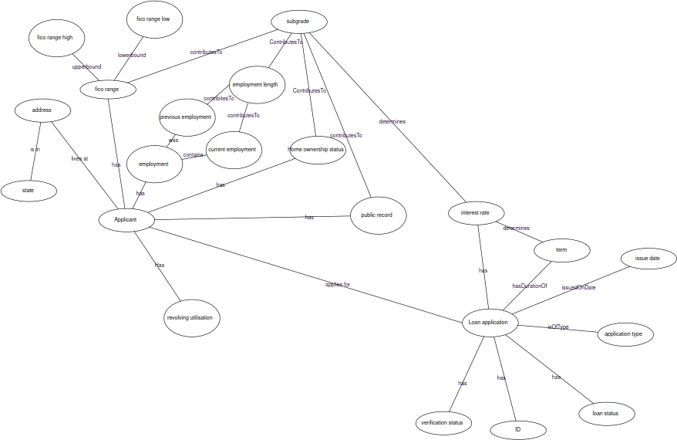
As existing vocabularies we used FIBO, especially the loan applications module (https://spec.edmcouncil.org/fibo/ontology/LOAN/LoansGeneral/LoanApplications/ ) and wikidata. The exact links can be found in the data shacl in the annexes as well as the rdf.
We added the following structure using Protege to extend the existing vocabularies.
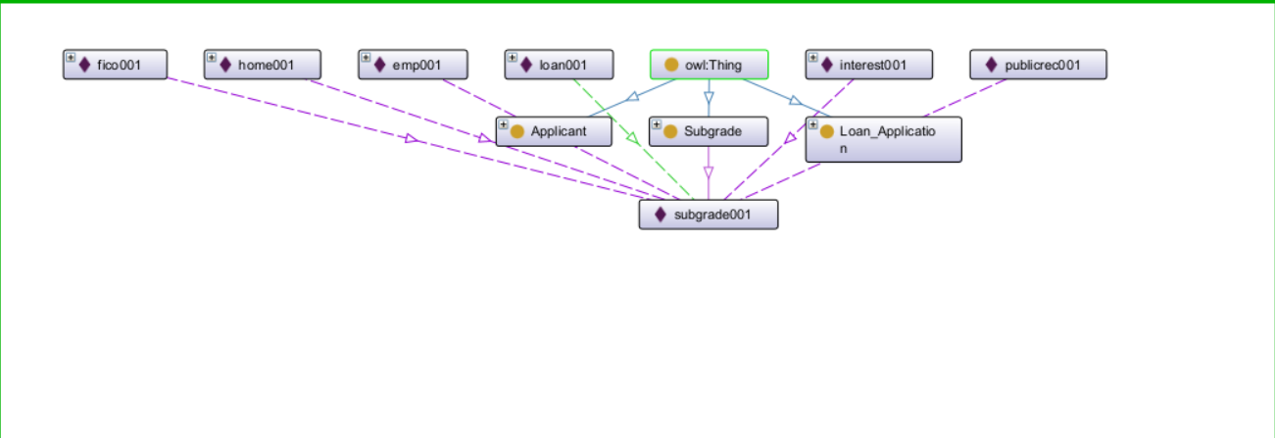
Using this, below is the updated semantic model (again made with draw.io) using the ontology names. For readability the hasValue fields and the full links have been left out.

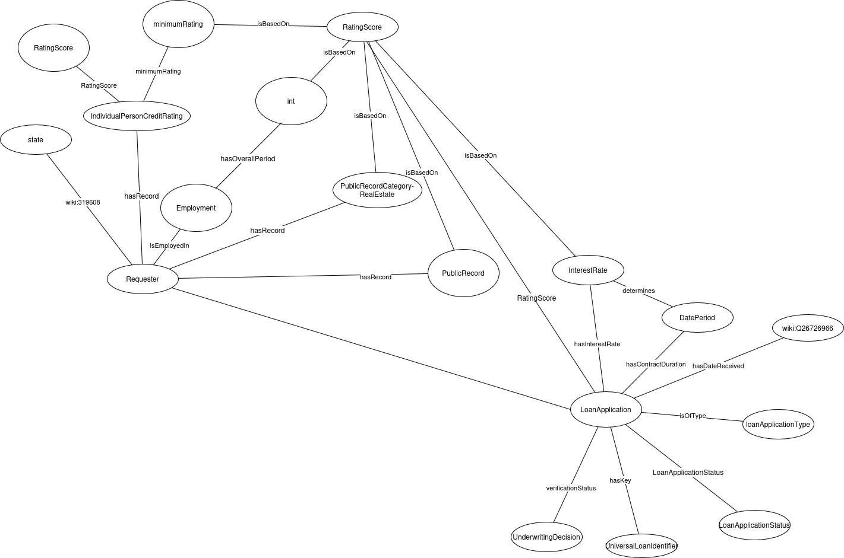

Data triplification
Within the triplification we did not include the current and previous employment as there we could not find URIs for such relations. Instead employment directly connects to employment length.
See the OpenRefine screenshots below for triplification.
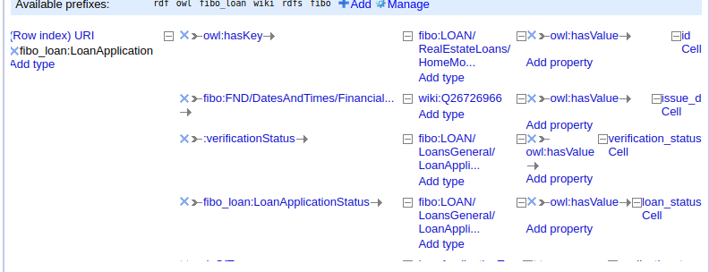

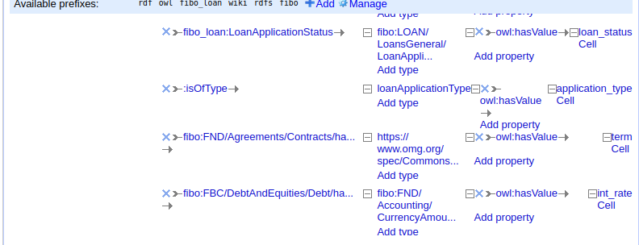
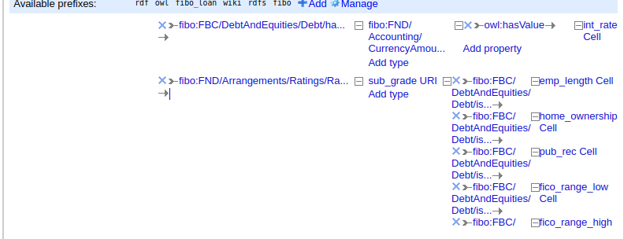

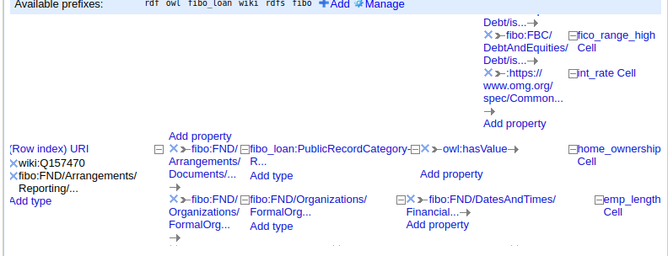

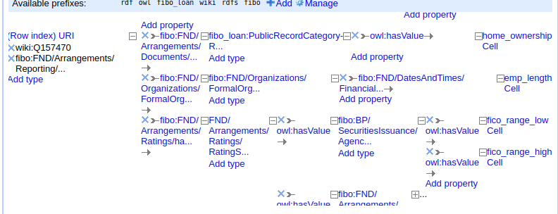
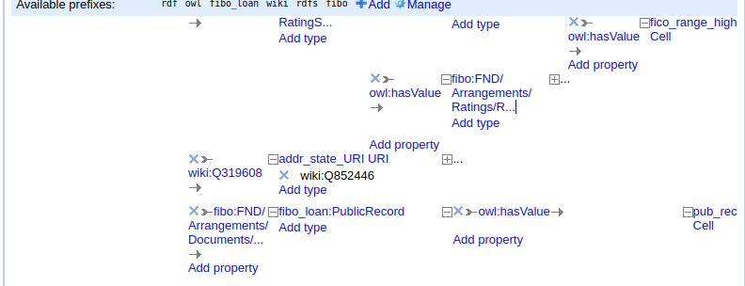

Semantic metadata model
See the metadata SHACL in the annex.
For the metadata we assumed that each dataset for loans will have differing amounts of information available. Next to the standard UI language, license and dates available we added the following fields:
Contact person (name & email) | This information allows a future user to contact the data steward for this data set with questions and issues regarding the dataset. We assume no dataset metadata form will be perfect for each use of the dataset. A way to contact a person who may have or know how to find the information for such uses, or can say it does not exist, saves future users time and guesswork.
Semantic model (URI) | Here the semantic model of the dataset can be linked. This improves accessibility and interoperability. By linking the model it does not have to be a Turtle or XML file but can also be a picture of a hand drawn graph.
Data source (URI) | An optional field for datasets based on other datasets. This is the link to the dataset pre-modification
Data provenance (text) | An explanation of how and why the dataset was created or modified. A text field allows for links without making a link to an outside project necessary.
Vocabularies used (URI) | This field adds context to the dataset and its semantic model. Adding the vocabularies used by the dataset also makes possible connections to other datasets (interoperability) more clear.
Data sample (text) | A simple excerpt from a record in the dataset. This gives a user a case to work from when programming.
Sample queries (text) | Example queries the database could answer.
Data management policy (text) | Indicates how long data and metadata will be available and how they may be used or changed over time. This can be a plain text expanation or a link to an external document
AI flag (boolean) | If true the data is synthetic data
Language(s) of the data (URI) | The language(s) used within the data restrict who can understand both the records and query results.
Extra information (text) | A complete form is rare. This text space allows the dataset uploader to add any notable information that did not fit other categories.

Metadata and data publication
[Links to the metadata record and to the data]

Final FAIRness assessment
Principle # | Criteria | Conformance pre FAIRification | Conformance post FAIRification | Note
F1 | Globally unique identifier | partially | partially
F1 | Persistent identifier | no
F2 | Has metadata | yes
F2 | Has rich metadata | partially
F3 | Has data identifier in metadata | yes
F3 | Has data identifier with clear predicate in metadata | no
F4 | Indexed/registered in search resource | yes
A1 | Has resolution protocol | yes
A1.1 | Protocol is open, free and universally implementable | yes
A1.2 | Protocol has authentication and authorisation mechanisms | yes
A2 | Metadata has longer persistency than data | no
I1 | (meta)data use a formal, accessible, shared, and broadly  applicable language for knowledge representation | no | yes | RDF through Turtle and SHACL
I2 | (meta)data use vocabularies that follow FAIR principles; |  | partially | Used vocabularies from FIBO and wikiData
I3 | (meta)data include qualified references to other (meta)data; |  | partially | The vocabularies used allow for easy referencing and linking to data within the domain
R1 | (meta)data are richly described with a plurality of accurate and  relevant attributes
R1.1 | (meta)data are released with a clear and accessible data  usage license
R1.2 | (meta)data are associated with detailed provenance; | partially |  | Some provenance was on kaggle/figshare

discussions and Conclusions

[Discuss your experience in going through the FAIRification process, the challenges and how you overcame the obstacles. Maximum 1 page ]

annexes

[Optional] Include references to supplementary material, source data, published FAIR resource (metadata and data), etc.
The metadata shacl
@prefix sh: <http://www.w3.org/ns/shacl#> .
@prefix schema: <http://schema.org/> .
@prefix rdfs: <http://www.w3.org/2000/01/rdf-schema#> .
@prefix xsd: <http://www.w3.org/2001/XMLSchema#> .
@prefix dash: <http://datashapes.org/dash#> .
@prefix foaf: <http://xmlns.com/foaf/0.1/> .
@prefix vcard: <http://www.w3.org/2006/vcard/ns#> .
@prefix ex: <http://example.com/> .
@prefix lexvo: <http://lexvo.org/id/iso639-1/> .
@prefix fair: <http://fairdatapoint.org/> .
@prefix dash: <http://datashapes.org/dash#> .
@prefix dct: <http://purl.org/dc/terms/> .
@prefix fdp: <https://w3id.org/fdp/fdp-o#> .
fair:FDPShape
a sh:NodeShape ;
sh:targetClass fdp:FAIRDataPoint ;
rdfs:label "Fair Data Point metadata";
sh:property fair:StartDateProperty,
fair:EndDateProperty,
fair:UILanguageProperty,
fair:MetaDataIdentifierProperty,
fair:MetaDataIssuedProperty,
fair:MetaDataModifiedProperty,
fair:ContactPersonProperty,
fair:SemanticModelProperty,
fair:DataSourceProperty,
fair:DataProvenanceProperty,
fair:DataVocabularyProperty,
fair:DataSampleProperty,
fair:DataSampleQueriesProperty,
fair:DataManagementPolicyProperty,
fair:DataAIgeneratedFlagProperty,
fair:DataLanguageProperty,
fair:LicenseProperty,
fair:ExtraInformationProperty;
.
#Groups are used to cluster questions together
fair:ContactPropertyGroup
a sh:PropertyGroup ;
rdfs:label "Contact";
.
fair:ContactPersonProperty
a sh:PropertyShape ;
sh:group fair:ContactPropertyGroup ;
sh:minCount 0;
dash:editor dash:DetailsEditor ;
dash:viewer dash:DetailsViewer ;
sh:name "Contact Person" ;
sh:node fair:ContactPersonDeets ;
sh:nodeKind sh:BlankNode .
fair:ContactPersonDeets
a sh:NodeShape ;
rdfs:label "Value with weight" ;
sh:property fair:NameProperty, fair:EmailProperty;
.
#E-mail of the contact person for the data
fair:EmailProperty
a sh:PropertyShape ;
sh:path schema:email;
rdfs:label "E-mail address";
sh:datatype xsd:string ;
dash:editor dash:TextFieldEditor ;
dash:viewer dash:LiteralViewer ;
sh:minCount 0 ;
sh:order 45;
.
#Name of the contact person for the data
fair:NameProperty
a sh:PropertyShape ;
sh:path schema:name ;
rdfs:label "Name";
sh:datatype xsd:string ;
dash:singleLine true ;
dash:editor dash:TextFieldEditor ;
dash:viewer dash:LiteralViewer ;
sh:maxCount 1 ;
sh:minCount 0 ;
sh:order 44 ;
.
fair:MetaDataPropertyGroup
a sh:PropertyGroup ;
rdfs:label "Metadata";
.
fair:StartDateProperty
sh:path fdp:startDate ;
sh:group fair:MetaDataPropertyGroup;
sh:datatype xsd:date ;
sh:maxCount 1 ;
dash:editor dash:DatePickerEditor ;
dash:viewer dash:LiteralViewer ;
sh:order 40 ;
.
fair:EndDateProperty
sh:path fdp:endDate ;
sh:group fair:MetaDataPropertyGroup;
sh:datatype xsd:date ;
sh:maxCount 1 ;
dash:editor dash:DatePickerEditor ;
dash:viewer dash:LiteralViewer ;
sh:order 41 ;
.
#UI language for FDP
fair:UILanguageProperty
sh:path fdp:uiLanguage ;
sh:group fair:MetaDataPropertyGroup;
sh:nodeKind sh:IRI ;
sh:maxCount 1 ;
sh:defaultValue <http://id.loc.gov/vocabulary/iso639-1/en>;
dash:editor dash:URIEditor ;
dash:viewer dash:LabelViewer ;
sh:order 42 ;
.
#ID that resolves to the metadata
fair:MetaDataIdentifierProperty
sh:path fdp:metadataIdentifier ;
sh:group fair:MetaDataPropertyGroup;
sh:nodeKind sh:IRI ;
sh:maxCount 1 ;
dash:editor dash:URIEditor ;
dash:viewer dash:LabelViewer ;
sh:order 43 ;
.
#When this metadata was uploaded
fair:MetaDataIssuedProperty
sh:path fdp:metadataIssued ;
sh:group fair:MetaDataPropertyGroup;
sh:datatype xsd:dateTime ;
sh:maxCount 1 ;
dash:viewer dash:LiteralViewer ;
.
#When the metadata was last modified
fair:MetaDataModifiedProperty
sh:path fdp:metadataModified ;
sh:group fair:MetaDataPropertyGroup;
sh:datatype xsd:dateTime ;
sh:maxCount 1 ;
dash:viewer dash:LiteralViewer ;
.
fair:DataPropertyGroup
a sh:PropertyGroup ;
rdfs:label "Data properties";
.
#License info
fair:LicenseProperty
sh:path fair:licenseProperty;
rdfs:label "Data license";
rdfs:comment "Add a license to the data";
sh:group fair:DataPropertyGroup;
sh:minCount 1;
sh:datatype xsd:string ;
dash:editor dash:TextFieldEditor ;
dash:viewer dash:LiteralViewer ;
.
#link to the semantic model(s)
fair:SemanticModelProperty
sh:path fair:semanticModel;
rdfs:label "Semantic model link";
rdfs:comment "The semantic model for the data and/or the domain of the data";
sh:group fair:DataPropertyGroup;
sh:minCount 0;
sh:datatype xsd:anyURI ;
dash:editor dash:URIEditor ;
dash:viewer dash:HyperlinkViewer ;
.
#link to the source of the data
fair:DataSourceProperty
sh:path dct:source;
rdfs:label "Data source";
rdfs:comment "Source of the data before current modification";
sh:group fair:DataPropertyGroup;
sh:datatype xsd:string ;
dash:editor dash:URIEditor ;
dash:viewer dash:HyperlinkViewer ;
.
#description of how dataset came to be / was changed
fair:DataProvenanceProperty
sh:path fair:provenance;
rdfs:label "Data provenance";
rdfs:comment "How was this data obtained and/or modified";
sh:group fair:DataPropertyGroup;
sh:datatype xsd:string ;
dash:editor dash:TextAreaEditor ;
dash:viewer dash:LiteralViewer ;
.
#List of vocabularies used
fair:DataVocabularyProperty
sh:path fair:vocabularies;
rdfs:label "Vocabularies used";
rdfs:comment "Links to any vocabularies used in the data or metadata ";
sh:group fair:DataPropertyGroup;
sh:datatype xsd:anyURI ;
sh:minCount 0;
dash:editor dash:URIEditor ;
dash:viewer dash:URIViewer ;
.
#Sample of data
fair:DataSampleProperty
sh:path fair:dataSample;
rdfs:label "Sample of data";
sh:group fair:DataPropertyGroup;
sh:data xsd:string ;
dash:editor dash:TextAreaEditor ;
dash:viewer dash:LiteralViewer ;
.
#Example queries
fair:DataSampleQueriesProperty
sh:path fair:sampleQueries;
rdfs:label "Example queries";
rdfs:comment "Examples of queries this dataset answers and/or how to query the dataset";
sh:group fair:DataPropertyGroup;
sh:datatype xsd:string ;
dash:editor dash:TextAreaEditor ;
dash:viewer dash:LiteralViewer ;
.
#Data management policy
fair:DataManagementPolicyProperty
sh:path fair:managementPolicy;
rdfs:label "Data management policy";
rdfs:comment "Describe or provide a link to the data management policy";
sh:group fair:MetaDataPropertyGroup;
sh:datatype xsd:string ;
dash:editor dash:TextAreaEditor ;
dash:viewer dash:LiteralViewer ;
.
#AI generated flag
fair:DataAIgeneratedFlagProperty
sh:path fair:aiFlag;
rdfs:label "AI generated/synthetic data";
sh:group fair:MetaDataPropertyGroup;
sh:datatype xsd:boolean ;
sh:minCount 1;
sh:maxCount 1;
dash:editor dash:BooleanSelectEditor ;
dash:viewer dash:LiteralViewer ;
.
#Language(s) of the data
fair:DataLanguageProperty
sh:path fair:dataLanguage;
rdfs:label "Language(s) used in the data";
sh:group fair:DataPropertyGroup;
sh:nodeKind sh:IRI ;
sh:minCount 0;
sh:defaultValue <http://id.loc.gov/vocabulary/iso639-1/en>;
dash:editor dash:URIEditor ;
dash:viewer dash:LabelViewer ;
.
#Space for additional information
fair:ExtraInformationProperty
sh:path fair:extraInformation;
rdfs:label "Additional information about the data";
rdfs:comment "Any additional information that may be useful to future users of this dataset";
sh:group fair:DataPropertyGroup;
sh:datatype xsd:string ;
dash:editor dash:TextAreaEditor ;
dash:viewer dash:LiteralViewer ;
.

DATA SHACL

@prefix sh: <http://www.w3.org/ns/shacl#> .
@prefix schema: <http://schema.org/> .
@prefix rdfs: <http://www.w3.org/2000/01/rdf-schema#> .
@prefix xsd: <http://www.w3.org/2001/XMLSchema#> .
@prefix ex: <http://example.org/> .
@prefix rdf: <http://www.w3.org/1999/02/22-rdf-syntax-ns#> .
@prefix owl: <http://www.w3.org/2002/07/owl#> .
@prefix fibo_loan: <https://spec.edmcouncil.org/fibo/ontology/LOAN/LoansGeneral/LoanApplications/> .
@prefix wiki: <https://www.wikidata.org/wiki/> .
@prefix fibo: <https://spec.edmcouncil.org/fibo/ontology/> .
@prefix local: <http://localhost:3333/> .
local:0 a fibo_loan:LoanApplication;
ex:isVerified "Not Verified".
fibo:Requester a rdfs:Class, sh:NodeShape ;
sh:targetClass <fibo:FND/Arrangements/Reporting/Requester> ;
sh:name "Applicant" ;
sh:property [
sh:path <https://spec.edmcouncil.org/fibo/ontology/FND/Arrangements/Documents/hasRecord> ;
sh:minCount 3 ;
sh:maxCount 3 ;
sh:property [
sh:path <fibo_loan:PublicRecordCategory-RealEstate> ;
sh:name "Home ownership type" ;
sh:minCount 1 ;
sh:maxCount 1 ;
sh:datatype xsd:string ;
sh:in (
"MORTGAGE"
"OWN"
"RENT"
)
];
sh:property [
sh:path fibo_loan:IndividualPersonCreditRating ;
sh:minCount 1 ;
sh:maxCount 1 ;
sh:property [
sh:path <fibo:BP/SecuritiesIssuance/AgencyMBSIssuance/minimumRating> ;
sh:name "Minimum fico value" ;
sh:minCount 1 ;
sh:maxCount 1 ;
sh:property [
sh:path owl:hasValue ;
sh:minCount 1 ;
sh:maxCount 1 ;
sh:datatype xsd:int ;
sh:minInclusive 300 ;
sh:maxInclusive 850 ;];
];
sh:property [
sh:path <fibo:FND/Arrangements/Ratings/RatingScore> ;
sh:name "Maximum fico value" ;
sh:minCount 1 ;
sh:maxCount 1 ;
sh:property [
sh:path owl:hasValue ;
sh:minCount 1 ;
sh:maxCount 1 ;
sh:datatype xsd:int ;
sh:minInclusive 300 ;
sh:maxInclusive 850 ;
];
];
];
], [
sh:path <fibo:FND/Organizations/FormalOrganizations/Employment> ;
sh:name "Total employment duration in years" ;
sh:minCount 1 ;
sh:maxCount 1 ;
sh:property [
sh:path owl:hasValue ;
sh:minCount 1 ;
sh:maxCount 1 ;
sh:datatype xsd:int ;
sh:minInclusive 0 ;
];
], [
sh:path wiki:319608 ;
sh:name "Address state" ;
sh:minCount 1 ;
sh:maxCount 1 ;
sh:datatype xsd:string ;
], [
sh:path fibo_loan:PublicRecord ;
sh:name "Number of public records" ;
sh:minCount 1 ;
sh:maxCount 1 ;
sh:property [
sh:path owl:hasValue ;
sh:minCount 1 ;
sh:maxCount 1 ;
sh:datatype xsd:int ;
sh:minInclusive 0 ;
];
], [
sh:path fibo_loan:LoanApplication;
sh:name "Application" ;
sh:minCount 1 ;
sh:nodeKind fibo_loan:LoanApplication ;
sh:class fibo_loan:LoanApplication ;
] .
fibo_loan:LoanApplication a rdfs:Class, sh:NodeShape ;
sh:targetClass fibo_loan:LoanApplication ;
sh:name "Loan application" ;
sh:property [
sh:path owl:hasKey;
sh:name "Loan ID" ; #TODO
sh:minCount 1 ;
sh:maxCount 1 ;
], [
sh:path <https://spec.edmcouncil.org/fibo/ontology/FND/DatesAndTimes/FinancialDates/hasDateReceived> ;
sh:name "Loan issue date" ;
sh:minCount 1 ;
sh:maxCount 1 ;
], [
sh:path local:verificationStatus ;
sh:name "Verification status" ;
sh:minCount 1 ;
sh:maxCount 1 ;
], [
sh:path fibo_loan:LoanApplicationStatus ;
sh:name "Loan approval status" ;
sh:minCount 1 ;
sh:maxCount 1 ;
], [
sh:path local:isOfType ;
sh:name "Loan application type" ;
sh:minCount 1 ;
sh:maxCount 1 ;
], [
sh:path <https://spec.edmcouncil.org/fibo/ontologyFND/Agreements/Contracts/hasContractDuration> ;
sh:name "Loan term" ;
sh:minCount 1 ;
sh:maxCount 1 ;
], [
sh:path <https://spec.edmcouncil.org/fibo/ontologyFBC/DebtAndEquities/Debt/hasInterestRate> ;
sh:name "Loan interest rate" ;
sh:minCount 1 ;
sh:maxCount 1 ;
], [
sh:path <https://spec.edmcouncil.org/fibo/ontologyFND/Arrangements/Ratings/RatingScore> ;
sh:name "Loan sub-grade" ;
sh:minCount 1 ;
sh:maxCount 1 ;
sh:in (
local:A1
local:A2
local:A3
local:A4
local:A5
local:B1
local:B2
local:B3
local:B4
local:B5
local:C1
local:C2
local:C3
local:C4
local:C5
local:D1
local:D2
local:D3
local:D4
local:D5
local:E1
local:E2
local:E3
local:E4
local:E5
local:F1
local:F2
local:F3
local:F4
local:F5
local:G1
local:G2
local:G3
local:G4
local:G5
) ;
] .
<fibo:LOAN/RealEstateLoans/HomeMortgageDisclosureActCoveredMortgages/UniversalLoanIdentifier> a rdfs:Class , sh:NodeShape ;
sh:property [ sh:path owl:hasValue;
sh:minCount 1 ;
sh:maxCount 1 ;
sh:datatype xsd:int;
].
<https://spec.edmcouncil.org/fibo/ontology/FND/DatesAndTimes/FinancialDates/hasDateReceived> a rdfs:Class , sh:NodeShape ;
sh:name "Loan issue date";
sh:property [
sh:path <wiki:Q26726966>;
sh:minCount 1 ;
sh:maxCount 1 ;
].
<wiki:Q26726966> a rdfs:Class ,sh:NodeShape;
sh:property [
sh:path owl:hasValue ;
sh:minCount 1 ;
sh:maxCount 1 ;
sh:datatype xsd:dateTime] .
<fibo:LOAN/LoansGeneral/LoanApplications/UnderwritingDecision> a rdfs:Class , sh:NodeShape ;
sh:name "Verification status" ;
sh:property [
sh:path owl:hasValue ;
sh:minCount 1 ;
sh:maxCount 1 ;
sh:datatype xsd:string ;
sh:in (
"Not Verified"
"Source Verified"
"Verified"
) ;].
fibo_loan:LoanApplicationStatus a rdfs:Class , sh:NodeShape ;
sh:name "Loan approval status" ;
sh:property [sh:path owl:hasValue ;
sh:minCount 1 ;
sh:maxCount 1 ;
sh:datatype xsd:boolean ;].
local:loanApplicationType a rdfs:Class , sh:NodeShape ;
sh:name "Loan application type" ;
sh:property [
sh:path owl:hasValue ;
sh:minCount 1 ;
sh:maxCount 1 ;
sh:datatype xsd:string ;
sh:in (
"Individual"
"Joint App"
) ;
].
<https://spec.edmcouncil.org/fibo/ontologyFND/Agreements/Contracts/hasContractDuration> a rdfs:Class , sh:NodeShape ;
sh:name "Loan term" ;
sh:property [
sh:path owl:hasValue ;
sh:minCount 1 ;
sh:maxCount 1 ;
sh:datatype xsd:int ;
sh:minInclusive 1 ;
].
<https://spec.edmcouncil.org/fibo/ontologyFBC/DebtAndEquities/Debt/hasInterestRate> a rdfs:Class , sh:NodeShape ;
sh:name "Loan interest rate" ;
sh:property [
sh:path owl:hasValue ;
sh:minCount 1 ;
sh:maxCount 1 ;
sh:datatype xsd:double ;
sh:minInclusive "0.0"^^xsd:double ;
].

We also endeavored to make the metadata form accessible to differing levels of technical know-how. While there is space for github links, official vocabularies, shacl files, and so on; it is also possible to upload a new dataset with text explanations and a public google drive link to the model.

